**Report of Role wise task Description for the Rent Payment Service.**

|  |  |  |  |
| --- | --- | --- | --- |
| **Sl. No.** | **Role Name** | **Task Name** | **Task Description** |
| 1. | **Supervisory Level of Head Clerk** |  |  |
| 1a | TM-2 | Verify and Application by Head Clerk for Rent | Supervisory Level of Head Clerk scrutinise the application.  If everything is okay then Head Clerk (Sl. No.- 1b) with Delivers for Rent Payment of Flat and Update Database.  Otherwise forward to applicant (Sl. No. -2b) for Shortfall for Document.  Or Rejects (Sl. No. -1d). |
| 1b | TM-3 | Approval by Head CLerk | Supervisory Level of Head Clerk approves. |
| 1c | TM-4 | Rejection | Supervisory Level of Head Clerk Rejects the Application by giving Remarks. |
| 3. | **Applicant** |  |  |
| 2a | TM-1 | Application Submission | Applicant apply and submit the Application to Head Clerk(Sl. no.-1a.) |
| 2b | TM-5 | Applicant Submission Shortfall | Applicant submit the Application with document to Supervisory Level of Head Clerk (Sl. no.-2a.) for Shortfall. |

Table of Task Mapping – TM

**Table of Task Mapping:-**

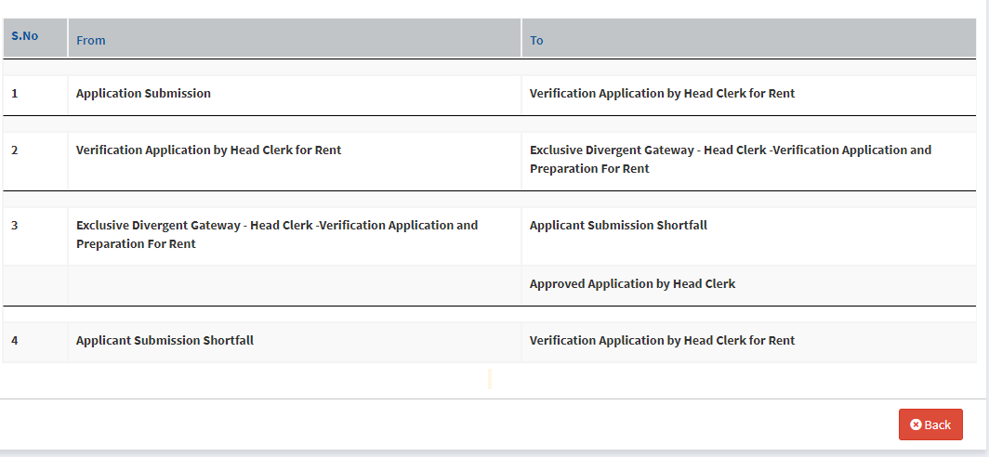

Service Plus Generated Flow Chart:

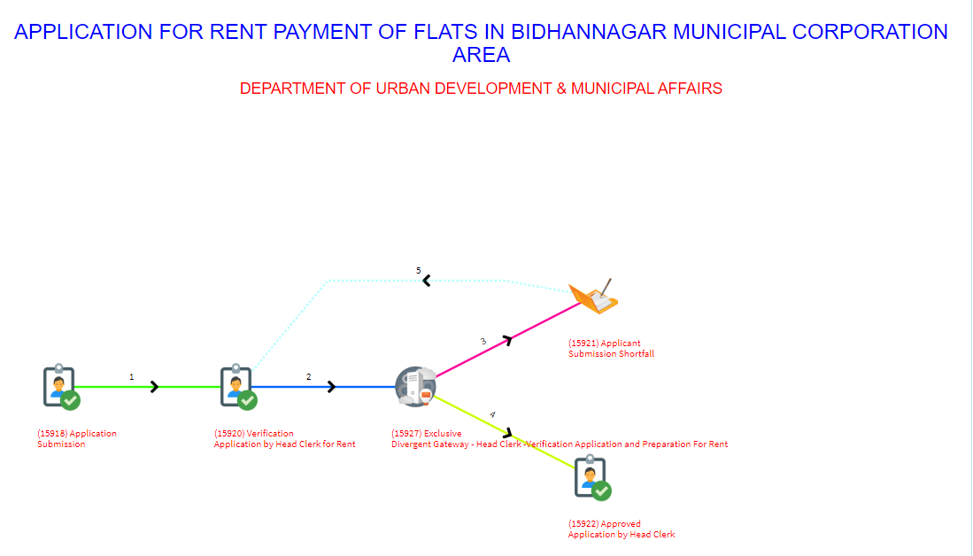

***Flow Chart for UDMA Rent Payment***

***Flow Diagram***

**OFFICE SECTION**

**HEAD CLERK**

*APPLICANT*

**2. Short Fall.**

**1. APPLICANT APPLY & UPLOAD PAYMENT RECEIPT**

API-1 Call to Get applicant data

**3. Application approval.**

API-2 Call for Payment Details updation in database

*APPLICANT*

**Description**

**STEP** **1:** Applicant will fill-up an Application form with required document and submitted to Head Clerk for Payment of Flat.

**API 1 Call-SP send JSON (flat no, license no) and Portal send response (Applicant details, flat details and Latest Month payment Details)**

**STEP 2:**  Head Clerk verify the application details and if found any issue than the application send back to applicant for modification of application details else go to Step 3.

**STEP 3:**  Head Clerk will approve the application and a rent payment acknowledgement send to applicant.

**API 2 Call-SP send JSON (App_ref_no, License_no, flat_no, amount, receipt_no, payment_date, payement_plan. pan_no, allotment_date ) and Portal send response(status- 0 for unsuccessful and 1- for successful updation in database and 2-for same application number).**

**Note:- This service is only for Non-Govt Employee.**